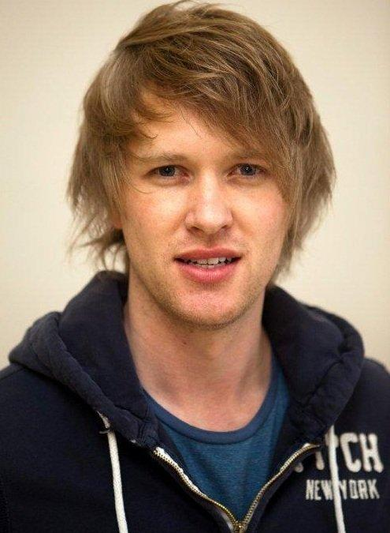
VICKUS HORNE
DOB: 29 April 1983
Height: 1.91
Hair: Blonde
Eyes: Blue
Languages: Afrikaans, English
Accents: British, American

TRAINING / EDUCATION:
National Diploma in Acting Tshwane University of Technology (2000 to 2000)

THEATRE:
Hamlet Artscape 2007/8

PRESENTING / MC:
Mc at Somerset Mall 2008
Mc at Cape Gate 2008/2010

MUSIC VIDEO:
Rasied Taha 2008

COMMERCIALS:
Nokia Siemens 2008
Mer Appel Juice 2009

SKILLS:
Singing
Juggling
Play Guitar/Bass Guitar/ Drums
Cricket

YOU TUBE LINKS:|
Finn.No Commercial: https://youtu.be/-tVq0mN0lTY
Justin Bridou Commercial: http://youtu.be/BBU2wkCK0xg
Heritage Bank Commercial: https://www.youtube.com/watch?v=pOX4Tm3SyDQ

