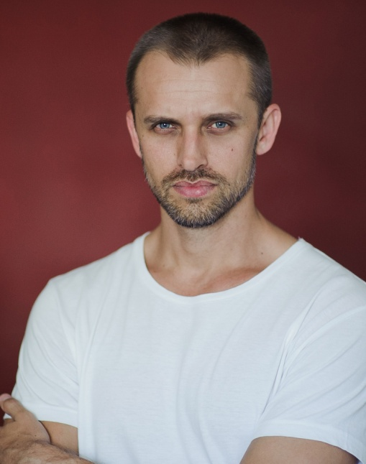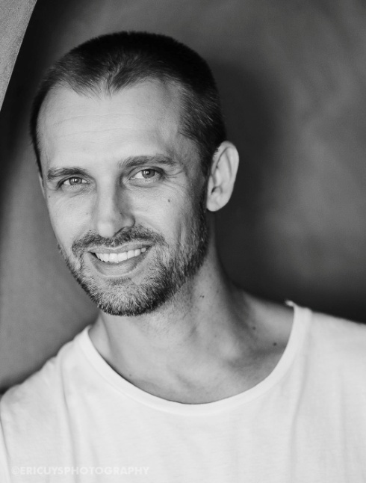
ERIC UYS

DOB: 23 September 1977
Height: 1.83m / 6’
Hair: Ash Blonde
Eyes: Blue
Languages: Fluent: Afrikaans, English - Basic: French, German, Japanese
Drivers License: A and EB (Motor car with trailer and Motorcycle)
Accents: American, British, French, German, Eastern European, South African Afrikaner
IMDB: http://www.imdb.me/ericuysactor

TRAINING:
Acting for screen – AFDA, The National School of Motion Picture Medium & Live performance (2003)
MBC Drama School – 2001 - 2002
Stunt performer at Stunt SA, Stunt Company (2003 till 2013)
2011 - Audition workshop with Paul Weber (Head casting director at MGM studios)
2013 - American Accent workshop with Judy Phillips
2015 -present, Actors Gym in Cape Town, on and off a weekly basis

FILM: ROLE: COUNTRY:
2003 BEAUTIFUL BONSAI Ben (Lead) RSA
2003 THE BED Kane RSA
2004 THE SACRED SCROLLS OF LIFE Egor (Lead) RSA
2004 LORD OF WAR Mobster # 1 WORLD
2007 Iniquity Thomas (Lead) RSA
2014 The Short Zed the FBI agent RSA
2014 CURSE OF HENDON Mercenary WORLD
2015 POP, LOCK n ROLL Ghengis (sup lead) RSA
2016 KROTOA Prison Official 1 RSA
2016 SPELONK DANTE (lead) RSA

TV SERIES:
2011 Mankind Tribal leader (stunts) Worldwide
2012 HOW WE INVENTED THE WORLD Frank Mcfarlane USA - DISCOVERY
2013 Black Sails Man at bar Worldwide
2016 Spelonk Dante (lead) RSA

COMMERCIALS:
2000 VETI-MARCHE Featured France
2002 COORS BEER Featured Canada
2004 NEXTEL Featured USA
2006 Smirnoff Hands RSA
2006 Goodyear Run on flatTyres Main stunt UK
2007 Simba Chips Stunt RSA
2012 Housebase UK Stunt rigger UK
2012 Chicken Licken Featured SA

SKILLS:
Martial arts Instructor (Ninjutsu, Combat and special forces), stunt work, motorcycle riding, horse riding, trampoline work, athletics, tennis, golf, paintball, beginner guitar and I am familiar and competent with various types of firearms, including, 9mm pistols, revolvers, Isreali UZI’s, AK-47’s, R1 & R4 assualt rifle’s, hunting rifles and shotguns as I shoot with live ammo on a weekly basis
Languages: French, German & Japanese (all basic with a decent accent)

YOUTUBE LINKS:
Showreel: https://www.youtube.com/watch?v=jPp4dgpNjPk&feature=youtu.be
Professor Hannes Engelbrecht on alcohol abuse and evolution
http://www.youtube.com/watch?v=dzcZcHBNpA4&feature=email
Chicken Licken Commercial - http://www.youtube.com/watch?v=RQai_IMUa0c

