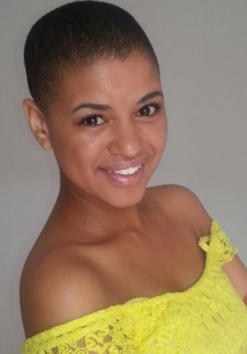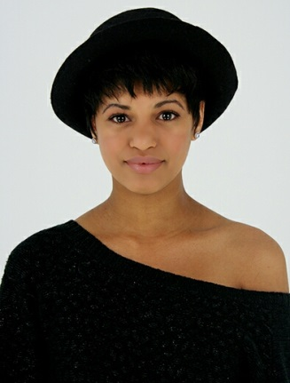
YENTL BOSMAN

DOB: 27 August 1991
Height: 156cm
Hair: Black
Eyes: Dark Black
Language: English/Afrikaans
Accents: Kaapse Afrikaans

EDUCATION:
Northlink Tygerberg BTECH Drama Diploma 2011 - 2012

FILM:
Sofia Grace and Rosie’s Princess Extra Princess Brian Levant 2014
THEATRE:
Zero to Hero (Children’s) Mermaid Albert Maritz 2015
Zero to Hero (Industrial) Abused Wife/Flamboyant Cleaner Albert Maritz 2015
Oyeah (Arepp) Julia Roxanne Ross 2014

MUSICAL THEATRE:
The Boyfriend Miss Dubennette 2011
Joseph & His Techinicoloured Dream Coat Narator 1 2012

COMMERCIALS:
Fruitare Beach Babe Extra 2013

SKILLS:
Singing: Mezzo-Soprano
Instrument: Recorder
Hockey & Gymnastics

YOUTUBE LINKS:
CCTV:
Joseph & His Techinicolour Dream Coat:

Awards:
Best Actress Award Of The Class Of 2012

