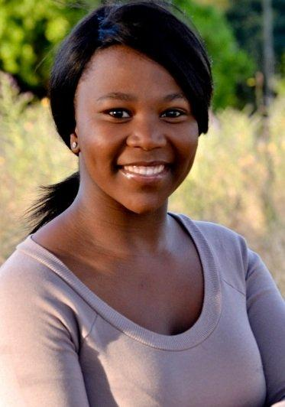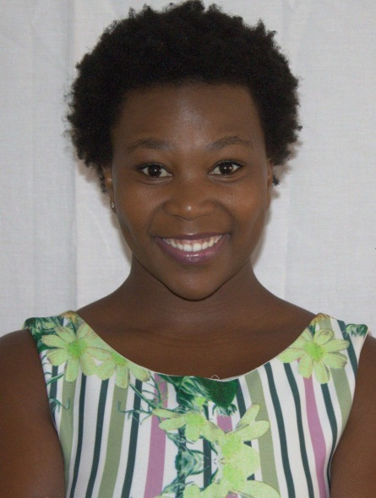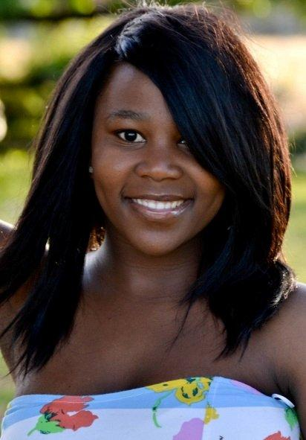
SONIA BUQWANA

DOB: 27 September 1990
Height: 1,50m
Hair: Black
Eyes: Brown
Language: Xhosa, English, Afrikaans
TRAINING/ EDUCATION:
North link College Tygerberg Campus - Trinity Guildhall of London 2009-2010
Bonnie Rodini Film and TV workshop – Technique 1 + 2 Director: Bonnie Rodini 2012-2013

THEATRE ROLE DIRECTOR YEAR
Sophia Town Lulu Nozuko Mtyingizane 2010
Cinderela Narrator Aphiwe Diko 2010
The Event Dr Mel Luthando Mthi 2014
Bash or be bashes Ncesh Thokozile Ntshinga 2014
Amaza xhosa setwork Assistant director Thokozile Ntshinga 2014
Amaza xhosa setwork Assistant director Thokozile Ntshinga 2015
Look before you leap Julia Kathlene Stevens 2015
About us steping up Gugu Kathlene Stevens 2016
Reza Dewets Missing Meisie Mdu Kweyama 2015
Reza Dewets Missing Meisie Mdu Kweyama 2016
Xhokaans Onehander Mandisi Sindo 2014

TV COMMERCIALS
Justine Bridou commercial 2013
Pepcell commercial 2014
Nestle Africa 2016
Saint Wines 2016

MC AND PRESENTING
MC Royal Baking powder, Celebrating 150 years 2013
Presenter: Takalani Sesame Roadshow 2014
Presenter Nutriday road show 2016
Presenter Calpol Roadshow 2016

SKILLS:
Acting, Dancer, Poet
Poetry
Dancing – traditional, contemporary
Set dressing
Applying make-up

