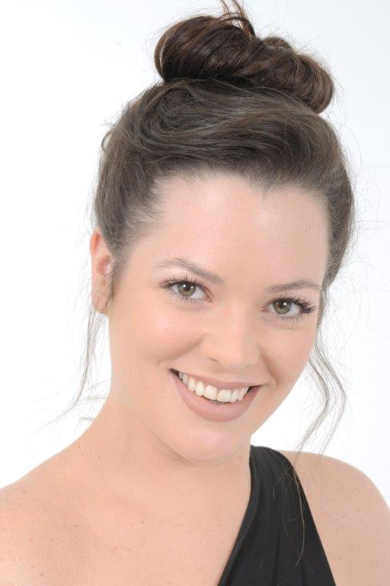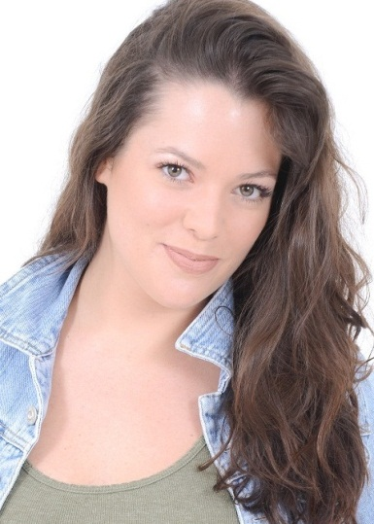
NIKITA FABER

DOB: 18 April 1993
Height: 1.69m/ 5.6
Hair: Brown
Eyes: Green
Language: English
Accents: Standard American & British RP

TRAINING:
ACT-2 Year Diploma Advanced Acting For Film (2014-2015)

FILM:
Dance of Chance Farrah Riaz Solker (Short Film) 2015

THEATRE:
The Pact Dillon Nicola Hanekom 2015

VOICE-OVER:
Malachi Entertainment Radio Retail 2015

SKILLS:
Musical instruments: Basic guitar (Acoustic)
Singing: Alto – Styles: Pop, Classical, Rock, Alternative, Jazz, Country.
Dance: Contemporary.
Sport: Running, Swimming, Athletics – Types: middle-distance, long-jump, high-jump.
Other: Comedic abilities, Yoga.
Hobbies: Cooking.

