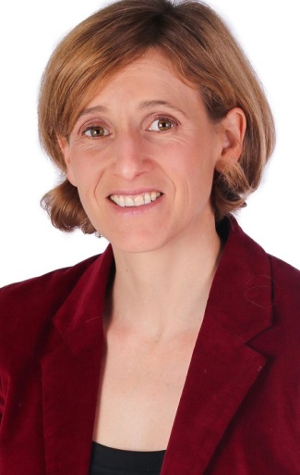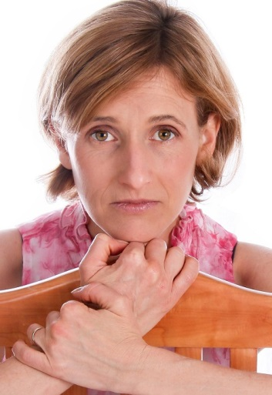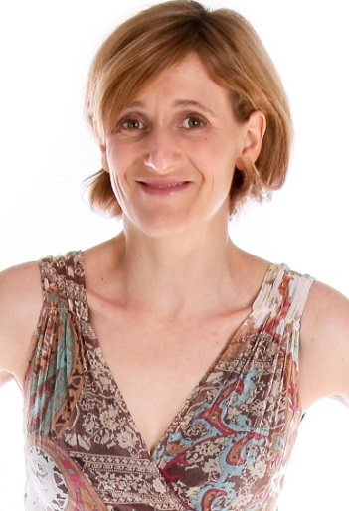
JENNY BRANDT

DOB: 23 October 1974
Height: 1.63 m
Hair: Light brown
Eyes: Hazel
Languages: English, Afrikaans
Accents: American, British

QUALIFICATIONS:
The Waterfront Theatre School Three year diploma in performing arts 1999-2001
Bonnie Rodini Introductory course in acting – 6 weeks 2012
ACT Auditioning for film – 3 weeks 2012
UNISA Bachelor of Arts with distinction 2001 - 2007

TV SERIES:
Unexplained Files - Documentary Marta Posse Trilogy Creative Studio 2013

ADVERTISEMENTS:
AAIME Llama wman 2015
FNB Boardroom Lead Fox P 2 2015
Rewe Supermarket Featured Extra Silk Stalkings 2014

DIRECTING:
Caryl Churchill’s ‘Top Girls’ Masque theatre 2016
Beth Henley’s ‘Crimes of the Heart’ Masque theatre 2015

THEATRE:

The Little Karoo (Pauline Smith’s) Solo performance Masque theatre 2017
Habeas Corpus (Alan Bennett’s) Connie Masque theatre 2016
Gaslight (Patrick Hamilton’s) Bella (lead role) Masque theatre 2015
The Hollow (Agatha Christie’s) Gerda Masque theatre 2014
Handful of friends (David Williamson’s) Wendy (lead role) Masque theatre 2013
Cyprienne (David Nicholson’s) Estelle Masque theatre 2013
The Odd Couple (Neil Simon’s) Florence (lead role) Masque theatre 2012
Hay Fever (Noel Coward’s) Jackie Masque theatre 2011
The haunted through lounge Felicity/Crematia Masque theatre 2011
Macbeth (Shakespeare’s) Various characters Masque Theatre 2011
The Crucible (Arthur Miller’s) Anne Putnam Masque Theatre 2011

SKILLS:
Playing piano.
Tango dancing.
Drama teacher for 4 years at Sweet Valley Primary.

HIGHLIGHTS:
Nominated for Best Actress in 2012 by CATA (Cape Town Amateur Theatre Awards)

