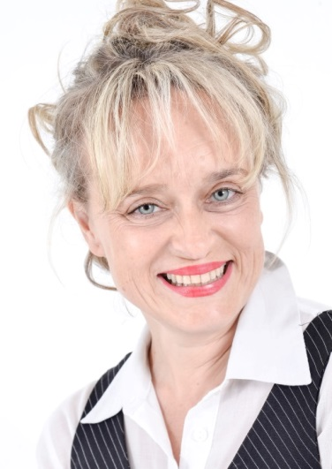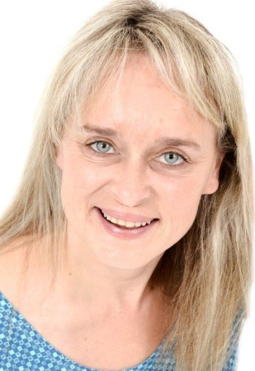
ILSE VAN NIEKERK

DOB: 19 February 1967
Height: 1,64m
Hair: Light Brown/Blond
Eyes: Green
Languages: Afrikaans, English.
Accents: Afrikaans (standard, all different dialects, formal accent); English (South African accent)

TRAINING:
ACT Cape Town Acting for film – Level 3 Nicola Hanekom 2015
ACT Cape Town Meisner, camera acting, film technique. Tamryn Speirs 2015
ACT Cape Town Standard American Accent Workshop Robyn Scott 2015
Screenact Studio Acting for camera Aletta Bezuidenhout 2013-4 Tony Perris
ADK 4 year Diploma - Theatre Maree Grobler 1985, 1986,
1987, 1989.
Refresher 2004

THEATRE:
People are living there Milly USAT 1986
Vroue van Troje Kassandra USAT 1985
Die Voelkou Wilde Een Framesby HS 1984
COMMERCIALS:
Coronation (South Africa) Mom Star Films 2016
FILM:
Nature Karen AFDA 3rd year Graduation Film 2015
SKILLS:
- Cycling (Mountain and road bicycle)
- Photography
- Yoga
- Can operate hand gun and rifle
- Knit and crochet
- Horseriding – a little
- Practised as an attorney
- Social worker
- Pilates

