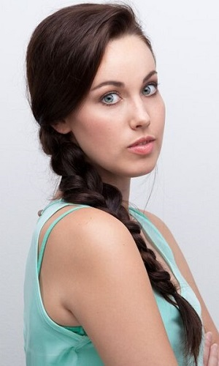
CLARA ROSSLEE

Date of birth: 26 June 1992
Height: 1.60m
Hair: Brunette
Eyes: Green
Languages: Afrikaans, English
Accents: British, American

EDUCATION/TRAINING:
Bonnie Rodini Acting Technique 1 2015
University of Cape Town Drama performance and studies 2012-2014
Dance performance and studies 2011-2014
Choreography studies 2011-2013
Linda Pienaar Dance Ballet 2006-2010
Academy Modern Dance 2001-2010

THEATRE:
Acting:
The Glass Menagerie Tom Wingfield 2014
Medea in the Mirror Erundina 2013
Bayen Bayen 2013
The Baobab tree Flamingo 2012
Dance:
Sun, Moon and River Mental Patient 2013
Giselle Wilis 2012
Les Sylphide Sylph 2011

SKILLS:
Dance: Contemporary, Ballet, Modern dance, Spanish, Physical Theatre, African
Choreography: Experienced
Musical Instrument: Drums (Basic level)
Yoga: Moderate level (flexible)
Sports: Tennis, Field Hockey
Hobbies: Horseback Riding, Running, Cartwheels, Hula hoop

