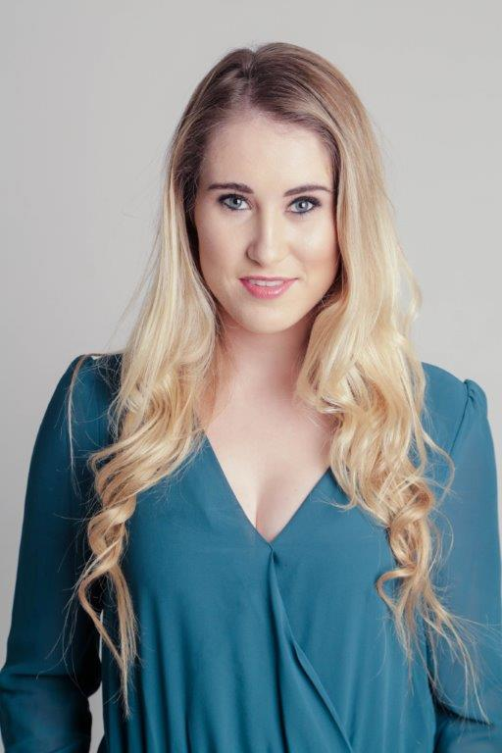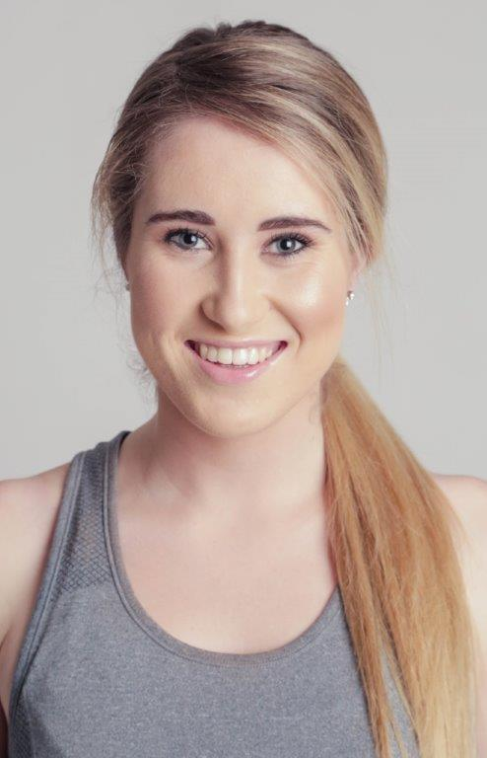
KELSEY GOULDIE

DOB: 02 April 1996
Height: 1,65
Hair: Blonde
Eyes: Blue/green
Language: English
Accents: English
RP
TRAINING:
ACT 2015 Higher Certificate in Acting for Film (1st year)
Tamryn Spiers Character work/ British Accent
Grant Swanby Acting for film/Voice
Nicol Ritchie Meisner Technique 1
Jason Delplanque Improv for actors

Rodini Films Acting course - Technique 1
Rodini Films Acting course – Technique 2
Rodini Films Audition workshop

EDUCATION:
High School Diploma, 11 (Parklands College - Cape Town)

Drama
Full colours for Dramatic Arts
SA Schools Festival Workshop 2012 (Artscape)
SA Schools Festival Workshop 2013 (Artscape)
Helen O’ Grady Drama Academy/School - 2010/2011

THEATRE:
Othello Lordvico 2013 - Artscape (Shakespeare festival)
Fiddler On The Roof Daughter 2009
Monkey’s Paw (One Act Play) Tourist 2013

EISTEDDFOD:
Poem 2012
Monologue 2013

SKILLS:
Swimming – professional squad training 2008- 2011
Kite Surfing
Qualified Life Guard – Big Bay Life Saving Club
Qualified Scuba Diver
Water Polo – Captain
Wake Boarding/ Skiing
Quad Biking

