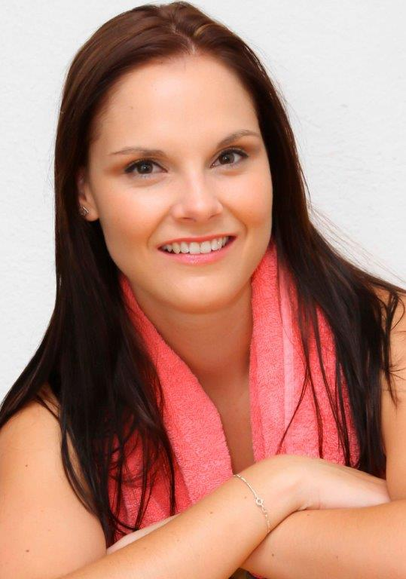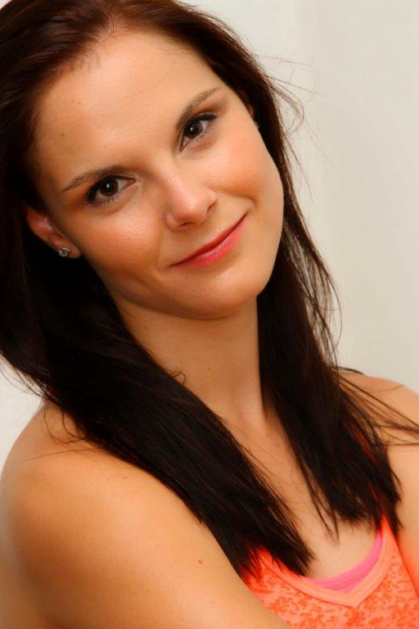
RACHELLE KRUGER
DOB: 5 March 1988
Height: 1.77 m
Hair: Brown
Eyes: Brown
Languages: Afrikaans, English
Qualifications: Studied Musical Theatre at the Waterfront Theatre College 2007-2010
Dance:  - Cecchetti Society Classical Ballet: Adv. 1  - ISTD Modern Theatre Adv. 2  - ISTD Gold Jazz  - ISTD Adv. 2 Tap  - ISTD Associate Diploma in Tap | Singing: Soprano (Vocal range: D3-E6)  - Gr. 7 Unisa Singing  - Musical Theatre LTCL  - Aviva Pelham Singing Trophy of 2008 by Waterfront Theatre College  - Most Outstanding Student of 2010 Award by Waterfront Theatre College

STAGE AND THEATRE:
Production  Variety  The Elves & The Shoemaker  Cinderella  Red Riding Hood  Pinocchio  Goldilocks  Peter Pan  An Evening with Rachelle  Silence of the Music  SA Artists for Aids  Awareness | Role  Singer, Dancer  Wife/  Choreographer  Godmother/  Choreographer  Woodcutter  Cat  Papa Bear  Wendy  Solo act  Maria, Lead  Solo and Ensemble | Type  Variety Show &  Solo Cabaret Show  Musical  Pantomime  Musical  Musical  Musical  Musical  Cabaret  Musical  Variety Show | Venue  MV Voyager  (Cruise Ship)  Al Rayyan Theatre, Doha (Qatar)  Al Rayyan Theatre,  Doha (Qatar)  Al Rayyan theatre,  Doha (Qatar)  Al Rayyan theatre,  Doha (Qatar)  Baxter Theatre,  Cape Town  Canal Walk,  Cape Town  MV Discovery  (Cruise ship)  Baxter Theatre, Cape Town  Baxter Theatre, Cape Town | Director  Andrea Lowde  Elton John Duffy  Elton John Duffy  Elton John Duffy  Elton John Duffy  Elton John Duffy  Fred Abrahamse  Andrea Lowde  Basil Appolis  Jimmy Earl Perry | Year  2014  2014  2014  2013  2013  2013  2013  2012  2011  2011

Television and Commercials:
Expresso Morning Show SABC 3  Internet Commercial –  Running Bride by Fresco Pictures | Singing and Interview about Silence of the Music  Modelling and Dancing | 2011  2010

CORPORATE WORK:
Pink Lunch Theatrical Corporate event Singing and Dancing Pigalle Dir. Janine Binns 2010
Truworths End of Year function Dancing Dir. Trix Vivier and 2008
Simon Marshall
CLIPS AND VIDEO’S:
http://www.youtube.com/watch?v=-dc3z1leDaQ Dance of Madness (Expresso clip)
http://www.youtube.com/watch?v=SWbgL-13ecc Taylor the Latté Boy
http://www.youtube.com/watch?v=8fDtol6ZEG4 Sound clips of original songs from my CD

BIOGRAPHY:
Rachelle could sing before she could speak and dance before she could walk. Discovered by the Tygerberg Children's Choir and SA Youth Choir, she performed as soloist at major occasions like the inauguration of Pres. Thabo Mbeki and travelled abroad to Canada; Spain, Sweden, Denmark and Wales.
She graduated end of 2010 from the Waterfront Theatre School, where she received her LTCL Musical Theatre Performers; Advanced 2 Tap; Associate Tap; Advanced 2 Modern; Gold Jazz and Advanced 1 Ballet. One of her highlights was receiving the Most Outstanding Student Award for 2010.
Rachelle has sung in numerous corporate events and weddings. One of her career highlights was playing the lead role of Young Maria in the musical, Silence of the Music, which showed in April 2011 in the Baxter Theatre. In 2012 she joined the MV Discovery, where she performed her own cabaret show, while seeing the world. In 2013 Rachelle played in numerous children’s theatre productions, while working on her debut CD. She is very excited to promote her self-titled album and to join the ship life in April till end of June on the MV Voyager, where she will be entertaining the passengers again.

