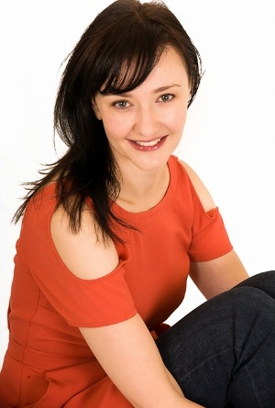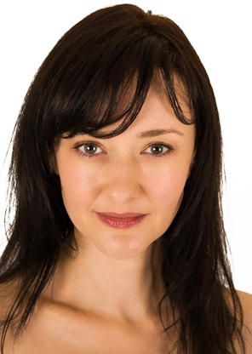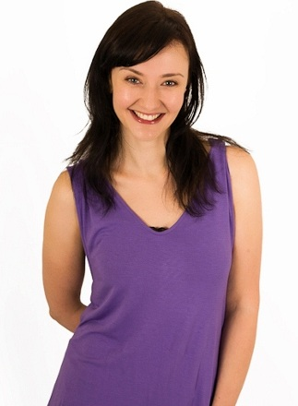
MARIA PRETORIUS

DOB: 19 February 1974
Height: 1.68
Hair: Brown
Eyes: Blue
Languages: Afrikaans, English, German
Accents: American, British, French, Italian

EDUCATION:
B.Mus.(Ed) University of Stellenbosch 1992-1995
Nat. Dip. Musical Theatre Pretoria Technikon 1999-2000
Acting Technique 1 & 2 Bonnie Rodini 2013, 2014
Audition Workshop Christa Schamberger & Digby Young 2013
American Accent Workshop Judy Phillips 2013

FILM:
Die Ontwaking Dorkas Advantage Entertainment 2014
Klankgrens Sandra Eric Uys (Short Film) 2014

TELEVISION:
Egoli Penny Franz Marx Films 2001
Girl van die Klein Karoo music video (girl) Geraas (SABC2) 2001
Duusman live Bass, vocals Draadloos (kykNET) 2001

THEATRE:
Don Giovanni stage musician CAPAB (Artscape) 1995
An Evening of Love Songs vocals, bass Brian Gibson (Plett Barnyard) 1996
Folk Classics I & II vocals, bass Brian Gibson (Plett Barnyard) 1996,1997
Rocking the Blues away vocals, bass Brian Gibson (Knysna Barnyard) 1997,1998
The Art of Two vocals, bass David Kantey (Knysna Barnyard) 1998
Glory Days vocals, bass Ian von Memerty (Sangita Barnyard) 2001

CORPORATE THEATRE:
LG Home Network mom Play: Modern Day Home 2005
Philips (Development Centre) business woman Role Play 2005

PRESENTER:
Emirates Overdrive Motor vehicle show Anant Duseja Productions 2002
Amiri Flight Entertainment Inflight Entertainment Oryx Productions 2003

COMMERCIALS:
Nokia (Asia) musician (featured) Moonlighting 2000
Wafi City (Dubai) mom (lead) Filmworks 2003
Toilet Duck (UK) tourist (featured) Filmworks 2006
A1 (Austria) orchestra member Velocity Films 2013
Canadian Tire (Canada) neighbour Gatehouse 2013
ABSA (South Africa) busker Velocity Films 2013

VOICE-OVER WORK:
Brides & Belles (USA) NBC Madison (television) 2007
Miller Law Firm (USA) Relevant Radio 1240 am 2007

STILLS:
LG, Fujitsu Siemens, Standard Chartered Bank, Gulf News, Belhoul Lifecare, Babyshop,
Hitachi, On Course Golf Magazine (cover), Avenue, Al-Futtaim Motors

MUSIC FESTIVALS:
Oppikoppi bass, vocals Duusman 1999,2000
Aardklop bass, vocals Duusman 1999
Afrikaans Kan Dans bass, vocals Duusman 1999

SKILLS:
Musical Instruments: Bass Guitar, Double Bass, Piano, Guitar, Clarinet, Flute
Singing: Alto/Mezzo – Styles: musical theatre, pop, classical
Dance: Salsa, Basic Ballet, Jazz, Tap, Musical Theatre
Other: Horse-riding, Yoga, Pilates

YOUTUBE LINKS:
Klankgrens: https://www.youtube.com/watch?v=6KsnmpIIBow&feature=youtu.be

