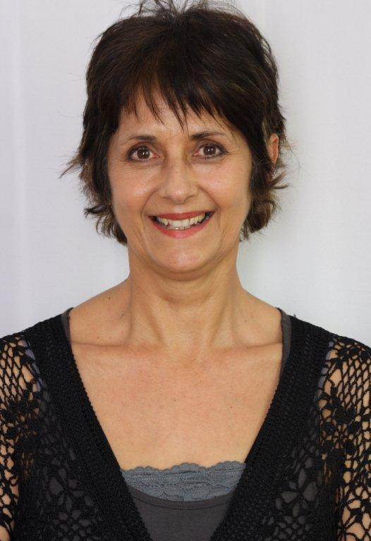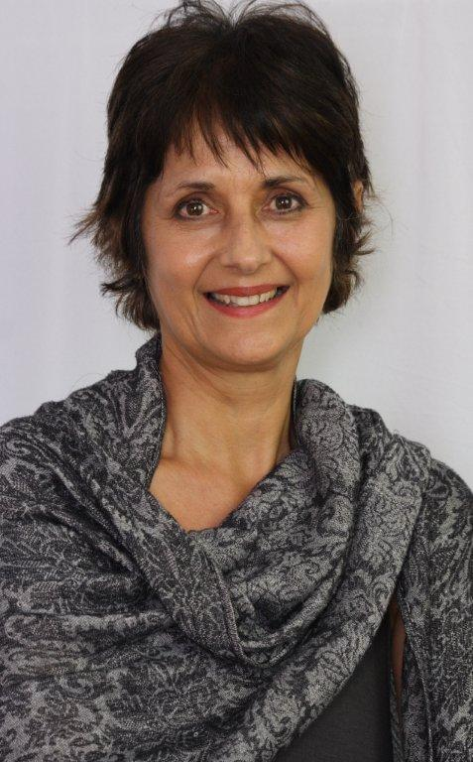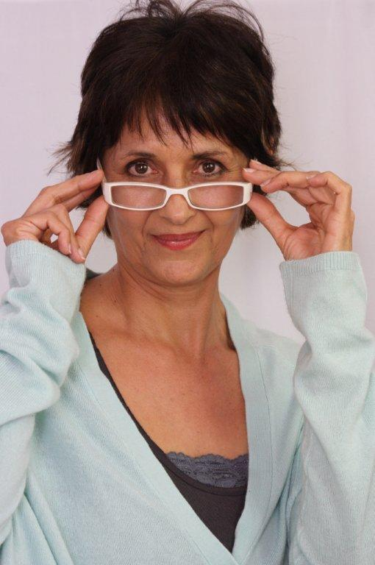
MARGOT WOOD

DOB: 12 December 1955
Height: 1,68m
Hair: Black
Eyes: Brown
Languages: English & Afrikaans (Fluent), some German, Dutch
Accents: All

QUALIFICATIONS:

Trinity College of London
University of Stellenbosch
Trinity College of London

University of Natal

University of Cape Town
University of Cape Town
FTCL (Directing)
MDram
Licentiate Teacher`s Dip Sp & Drama
Honours in Drama (Acting&Directing)
Performer`s Diploma Sp & Dr
BA (Drama)
2010
2001
2001

1986

1977
1976

FILM:

Judge Dredd
Italian Consul
Chimes (short film)
Mother
Mother of bride
Mother
2011
2010
2006

TV SERIES:

History of the World
Crusoe
Orion
Fishy Feshuns
Species Odyssey
Redding
Minoan Priestess
Maid
Dinner guest
Easter European client
Cro Magnum mother
Skipper`s daughter
2011
2008
2005
2004
2004
1977

THEATRE:
Happy Days Winnie 2013

Global Ballgame
People are living there
A sense of the Absurd
The Glass Menagerie
El Grande de Coca cola
Bar & Ger
Seder val in Waterkloof
(Director Schalk Jacobz)
Plaston DNS Kind
(Director Hermien Dommisse)
The Miser
(Director Jannie Gildenhuys)
Various roles and director
Milly and director
Various
Amanda and director
All female roles
Ger
Poppie

Kotie

Elise

2012 National Arts Festival
2010 Fugard Festival
2008
2007
2006-2007
2006
1979

1979

1978

(Director Pieter-Dirk Uys)
Boeing Boeing (Director Sandra Jacqueline 1978
Kotze)
The Rise&Fall of the first Empress Josephine 1977
Bonaparte

CHILDREN`S THEATRE:

Towerwolf
WAM
Die Avonture van Heidi
Hansie die Hanslam
Die Getoorde Boom
Senor Onyon
The Magic Pouch

Mother
Maria Theresa
Rottenmeier
Slagter se vrou
Malatsepa
Great-grandmother
The witch of Itch

Woordfees 2008
KKNK 2006 &Suidoosterfees 2006
1979
1978
1978
1977

Puppets shows, storytelling& Children`s theatre for Storywood Theatre eg at Bugz Playpark, Worcester casino, Paarl Mall, Vital Family Day, PicknPay Family Day
2006-2010
Industrial theatre projects eg GIS launch for Dept Environmental Services
2005, 2011
Corporate Theatre John Rolfe 2005

COMMERCIALS:

Cymbalta
IEC
Tea
Cadbury
USA/Canada
SA
Saudi Arabia
UK
2010
2005
2004
2003

VOICEOVERS:

Radio drama
Dubbing eg

Pendoring&Kie
Faber
Nils Holgerson
1981
1988
1988

AWARDS:
Overall winner People are living there at Fugard Festival 2010 (director & actor-role of Milly)
Best Production The Captain`s Tiger at Fugard Festival 2011 (Director)

SKILLS:
Dancing: Ballroom, Spanish , Ballet, Modern, Jazz, Tap, Yoga & Tai chi, Piano, Painting, Pottery, Singing

BIOGRAPHY:
I have been a freelance actor, director, puppeteer and voice artist since 1978 when I started my career as fulltime actor at SWAPAC. I have also been involved in the teaching of drama since 1983 and have run my own Speech and Drama studio since 1988. I founded my own theatre company, Anex Theatre, in 2006 and have been directing and producing plays, mainly for Festivals, since that time. I am interested in Ancient History and obtained a MPhil (Ancient Cultures) in 2011.

