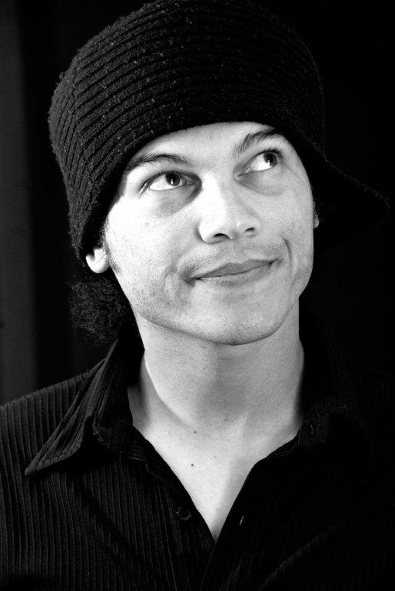
LUKE JANSEN

DOB: 12 January 1980
HEIGHT: 1.74m
EYES: Green
HAIR: Dark brown / black
LANGUAGES: English and Afrikaans
ACCENTS: Irish and Scottish

TV/ FILM:
PSA for Carel Du Toit Centre (Dir.: Wicus Labuschagne)
Montana – Season 2
Colour TV – Season 1
Watch your back – Independent Film (Dir.: Gordon Clark)
Letters to the dark – Student Film (Dir.: Kyle Lewis)

THEATRE:
C.O.C.T. Saving Electricity
Theatre towards a healthy society: TB
Lighthouse Ministries Easter Production – Jesus Christ
Are We Ready! – Directed by Christo Davids

CORPORATE:
Eskom LIVEWIRE PROJECT
Royal Baking Powder MC and Brand Promoter 2013

VOICE OVERS:
ESKOM – LIVEWIRE PROJECT

YOU TUBE LINKS:
Kauai Commercial: https://www.youtube.com/watch?v=7AMz7csNKhE&feature=youtube_gdata_player
Justin Bridou Commercial: http://youtu.be/BBU2wkCK0xg

