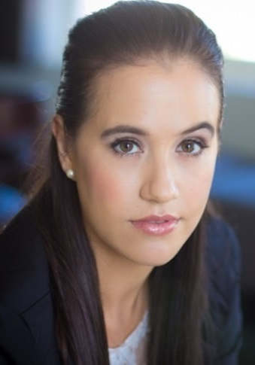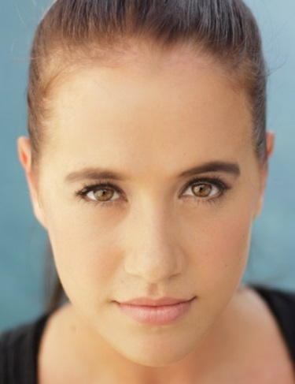
LARA COETZEE
DOB 23 March 1990
Height 1.68 M
Hair Brunette
Eyes Hazel
Languages Afrikaans; English
Accents RP English, Cockney, American, British, Southern American, Italian, French, Indian, Coloured SA

QUALIFICATIONS:
University of Stellenbosch (2011) BA Drama (Specialization: Cabaret)
SA Guild of Speech and Drama (2008) Training and Exams (up to Teachers)
UNISA (2008) Classical Vocal Training (up to Grade 5)
Trinity College of London Rock School (2007) Rock Vocal Training (up to Grade 5)
S.A.D.T.A Modern Dance Association (2009) Training and Exams (up to Teachers)
R.A.D (Royal Academy of Ballet) (2008) Training and Exama (up to Advanced 1)
S.A.D.T.A Hip Hop Association (2006) Training and Exams (up to Level GOLD)

FILM:
Bakgat “Schoolgirl” Dir. Henk Pretorius 2007

TELEVISION:
Kyk-Net Hartiwood’s “Jy’s my liefling” Contestant Top20 (2013)
M-net Pieter Toerien’s Spotlight SA: High School Musical Contestant (2008)
MK89 MKSer: Comedy Skits Nerdy girl (2010)

THEATRE:
Eve-o-lution: a Cabaret “Female Allegory” Dir. and Writer Lara Coetzee (2011)
Dracula “Vampire Bride” “Gypsy singer” Dir. Zoetje Hofmeyr (2011)
Vou “Law student Parody” Dir. and co-writer Lara Coetzee (2009)

MUSICAL THEATRE:
Peter Pan - Canal Walk’s Mrs. Darling/Tiger Lily/Mermaid Dir. Fred Abrahamse & Marcel Meyer
Versversnit (KKNK) Actress & Singer Dir. Louis du Preez
Versversnit (KKNK) Actress & Singer Dir. Louis du Preez
Grease the Musical (Artscape) “Rizzo” Dir. Ignatius van Heerden
Storielied (by Luna Paige) Backup Vocalist Dir. Albert Maritz
Cinderella “Cinderella” “JUK” (Jong uitvoerende Kunstenaars)
Charlie Brown Dancer and Chorus “JUK” (Jong uitvoerende Kunstenaars)
Broadway Numbers Dancer and Soloist “JUK” (Jong uitvoerende Kunstenaars)
Fusions Dancer and Soloist “JUK” (Jong uitvoerende Kunstenaars)

SKILLS:
Singing: Range: F below MC, to C above MC (Belting), to 2 above MC (Head voice).
Trained: Classical, Rock, Jazz, Blues, Musical Theatre

DANCING AND CHOREOGRAPHING:
Modern Dancing, Ballet, Hip Hop, Jazz, Contemporary.
SA Dance team to Los Angeles for World Championships (2005)
Head Choreographer of dance group, J’adore (2010-2012 )
Current dance coach at College of Performing Arts (Wellington)

