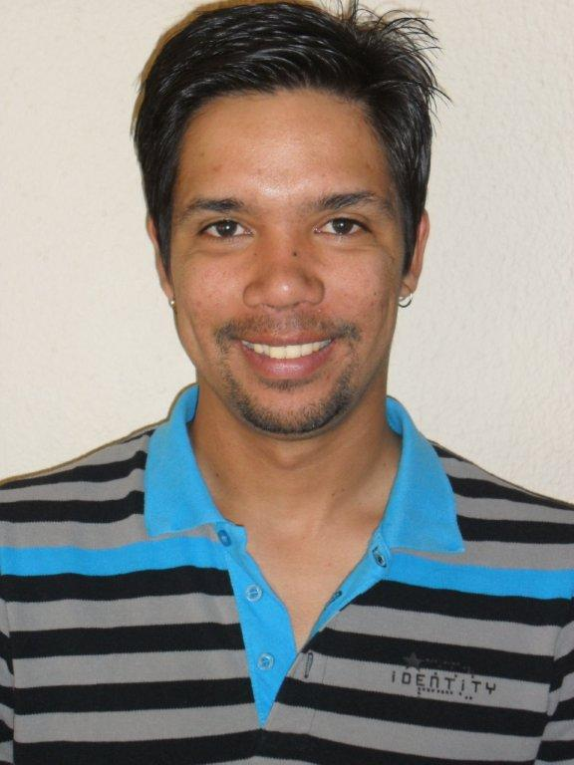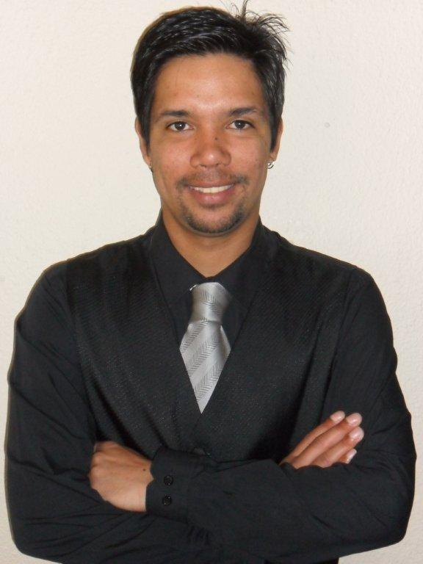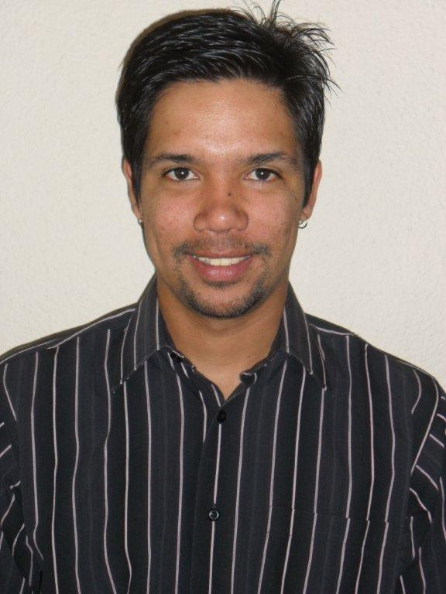
KEENAN HERMAN
D.O.B 08 August 1987
Height: 1.78m
Hair: Black
Eyes: Brown
Languages: Afrikaans, English
Accents: American, British

TRAINING:
Date Institution Description Coach
2007 Northlink College Drama (Acting, voice, movement, Gideon Van Eeden/Albert Maritz
dance, Theatre, music, film) Nicol Holm/Abduragmaan Adams
2008-2009 Saturday Varsity Training in Shakespeare,
writing and performing poetry Abduragmaan Adams, Tauriq
Jenkens, Tinarie Van Wyk Loods

THEATRE:
PRODUCTION TITLE ROLE DIR.
Live Rage: Tribute to James Mathews Michael Wentworth
Progress Michael Wentworth
T.B awareness campaign Ivan Abrahams & Andre Samuels
Theatre towards a healthy society Andre Samuels
Othello Iago Tauriq Jenkens
Coconuts &Marullas Lead TauriqJenkens
Save Electricity Campaign Andre Samuels/Ivan Abrahams

FILM TITLE DIR.
Natural Law Gangster Aaron Naidoo
Steaorra Gangster Desmond Denton

SKILLS:
Dancing
Singing
Drama teaching at workshops
Poetry writing and performance

