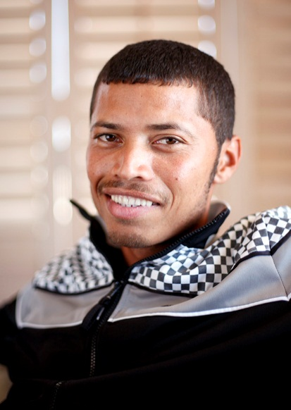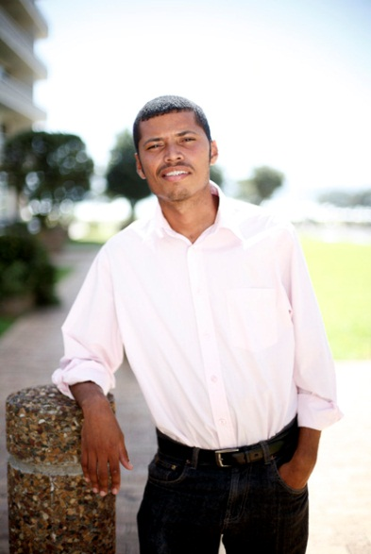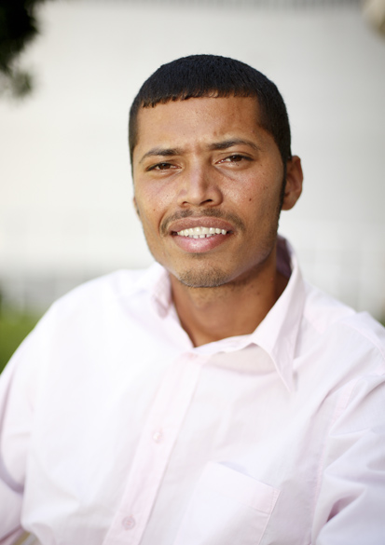
JEREMIAH MENTOR

DOB: 20/11/1986
Height: 1.65
Hair: Black
Eyes: Brown
Languages: English, Afrikaans
Accents: British, American

DRAMA TRAINING:
Drama Course: Batswood art centre `97-`99
Denver & Delilah films `07-08
Helen o grady drama academy

THEATRE:
Jandorie & delorex – Lead
The Kidnaping of Kitty o hara - puppet show

MOVIES /DOCUMENTRIES:
LACONIA(POW)
JUDGE DREDD
SAFE HOUSE
CHARITY EVENT
LOCKED UP ABROAD
MANKIND
HISTORY OF THE WORLD

COMMERCIALS:
MTN Ayoba (fan)
Vodacom (fan)
Rice Crispies

HOBBIES:
Soccer, cricket, tennis, swimming, karate, cycling

